Class: CIS434 Software Engineering

Subject: User’s guide

Team members: Parth Patel & Shardul Panchal

**Introduction**

**Purpose**

This guide is designed to help users understand how to navigate and use the healthcare patient management application effectively. It provides step-by-step instructions for registering, booking, and managing appointments.

**Overview**

The application enables:

* Patients to register, book, and manage appointments with doctors.
* Administrators to oversee and manage appointments.

This guide includes instructions and visuals to ensure a seamless user experience.

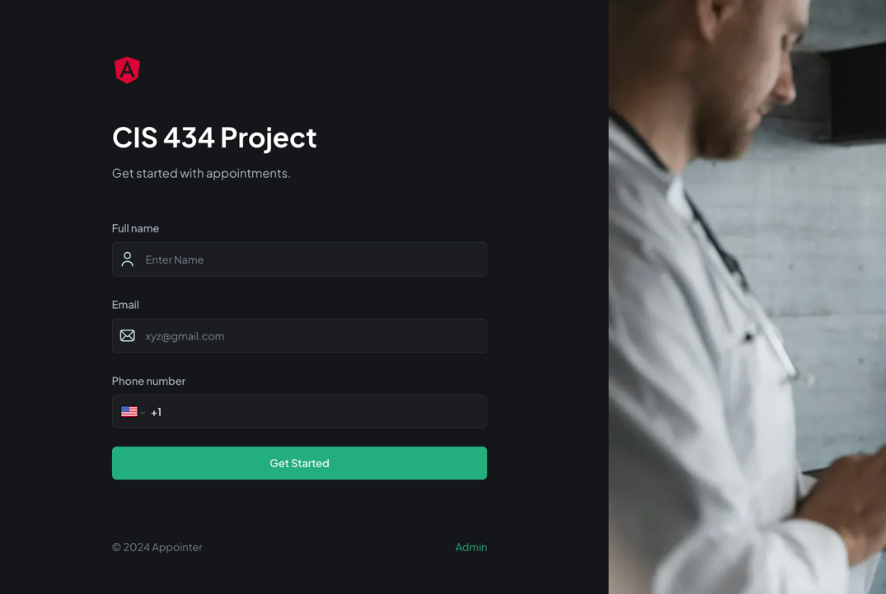

* The first screen you will have when you open the HealthCare website.
* Enter your name, phone number and email ID, which can be @yahoo, @gmail, etc.
* The purpose of getting your information is to contact you or update you if anything unusual occurs.
* You can click on the “Get Started” button.

2nd Page (Welcome)

* If you’re a registered user, then you can put in your credentials, and it will log in.

* A screenshot of a computer

  Description automatically generatedYou have to put your personal information and medical information, and for identification and verification, you have to choose from the dropdown menu, e.g., choose your birthdate, and you have to enter your birthdate.
* Some of the consent and privacy policies to use the service.

* Now, you can set up an appointment with the Doctor by clicking the dropdown menu and selecting an availability accordingly.
* Have to provide an appointment reason and comments/notes to schedule an appointment.

* After setting up the appointment, you can see the confirmation page with the doctor’s name and your appointment date and time.

For admin users:

If you click on the admin button below on the login or sign-up, the admin has to use their pass key to verify it, and then you can log in.

* The admin screen will look like this: we can see all the appointments that the user made. The doctor can also access it and cancel the appointment if they have to change their schedule.